HOME AUTOMATION USING NODEMCU

WITH BLYNK 2.0

**Components :**

You can make this project just by using NodeMCU and 2-channel relay module • NodeMCU

• Relays 5v (SPDT) (2 no)

• LED 5-mm (2 no)

• Terminal Connectors

• 5V DC supply

• Jumper Wires

• Blynk2.0

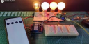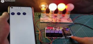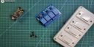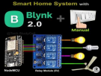

https://youtu.be/CpUVssHPm_

s

Page 1



**Step 1 : Circuit Diagram for NODEMCU**

The circuit is very simple, I have used the GPIO pins **D1, D2** to control the 2 relays.

I have used a 5V mobile charger to supply the smart relay module. the booting process of NodeMCU.

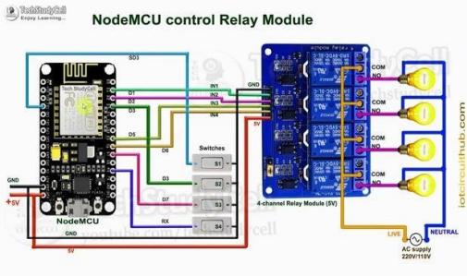

**Step2 : How Blynk IOT works.**

If the **NodeMCU** is connected with WiFi, then you can the relays from anywhere in the world with the Blynk IoT In this way, all smartphones will be control the home appliances from **Blynk IoT App**. You also use **multiple smartphones** to control the appliances with Blynk App.

Page 2



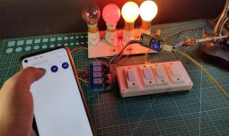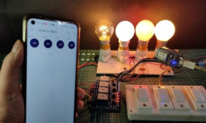

**Step 3: Control Relays Manually With Switches**

You can also control the relays from the switches or pushbuttons. You can monitor the real-time feedback in the Blynk IoT App. Please refer to the circuit diagram to connect the pushbuttons or switches.

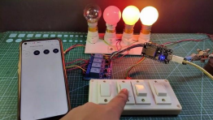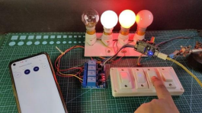



**Step 4: Create Blynk Cloud FREE Account**

For this smart house project, I have used the **Blynk IoT Cloud Free plan.**

Click on the following link to create a Blynk Cloud account.

https://blynk.cloud/dashboard/register

1. Enter email ID, then click on "**Sign Up**". You will receive a veri cation email.

2. Click on **Create Password** in the email, Then set the **password**, click on **Next**.

3. Enter your **rst name**, click on **Done**.

After that Blynk cloud dashboard will open.



**Step 10: Create a New Template in Blynk Cloud**

First, you have to create a template in the Blynk cloud.

1. Click on **New Template.**

2. Enter a template **name**, select the hardware as **ESP8266**, and the connection type will **WiFi**. 3. Then click on **DONE**.

You will get the **BLYNK_TEMPLATE_ID** and **BLYNK_DEVICE_NAME** after creating the temple. The BLYNK_TEMPLATE_ID and BLYNK_DEVICE_NAME will be required while programming the NodeMCU.





**Step 11: Create a Datastream in Blynk Cloud**

After that, you have to create Datastreams. Here I will control 4 relays, so I have to create 4 Datastreams.

1. Go to the **Datastreams** tab.

2. Click on **New Datastream** and select **Virtual Pin**.

3. Enter a **name**, select the **virtual pin V1,** and the datatype will be **Integer**.

4. Then click on **Create**.

In a similar way, create 4 datastreams with virtual pin **V1, V2, V3**, and **V4.**





**Step 12: Set Up Blynk Cloud Web Dashboard**

Now go to the web dashboard tab.

Drag and drop 4 Switch widgets.

Go to the settings of each widget, and select a Datastream.





**Step 13: Install Blynk IoT App to Configure Mobile Dashboard**

1. Install the **Blynk IoT app** from Google Play Store or App Store. Then **log in.**

2. Go to **Developer Mode.**

3. Tap on the **template** that you have already made.

4. Now go to the **Widget box** (on the right) to add widgets.



**Step 14: Add Widgets in Blynk IoT App**

1. Add **4 Button** widgets from Widget Box.

2. Go to **Button widget settings**.

3. Enter the **name**, select **Datastream**, Mode will be **Switch**. Then exit.

4. After setting all the Buttons tap on **exit**.





**Step 15: Program the NodeMCU for This Blynk Project** First, download the code from the following link.

https://drive.google.com/ le/d/1WK6AOzVyS

~~P6G32mK..~~

You have to keep all the 9 les in the same folder.

Open the **.ino le** in Arduino IDE.

In the code, you have to update the

**BLYNK_TEMPLATE_ID** and

**BLYNK_DEVICE_NAME.**

For this project, you have to install the **Blynk**

**1.0.0 beta.3** & **AceButton** libraries.

Now select the NodeMCU 1.0 board and proper

PORT.

Then upload the code to NodeMCU Board.



**Step 16: Update the WiFi Credentials Through OTA**

After programming the NodeMCU, you have to update the WiFi credentials from the Blynk IoT app.

In the tutorial video, I have explained all the steps to update the WiFi credentials to NodeMCU through OTA. 

**Step 17: Connect the Home Appliances**

Connect the **4 home appliances** with the relay module as per the circuit diagram.

**Please take proper safety precautions while working with high voltage.** Connect 5-

volt DC supply with the PCB. (I have used my old mobile charger 5V 2Amp)





Turn on the **110V/230V** supply and **5V** DC supply.

**Step 18: Finally!! the Blynk Smart Home System Is Ready**

Now you can control your home appliances in a smart way.

I hope you have liked this new **Blynk home automation project**. I have shared all the required information for this project.

I will really appreciate it if you share your valuable feedbacks. Also if you have any query please write in the comment section.

Thank you & Happy Learning.

